**Mid-season email template**

**Directions on how to use the email templates:** copy all of the content below, including the banner graphics and text, and paste content into a new email. You may then customize the text and send to your employees, customers, patrons etc.

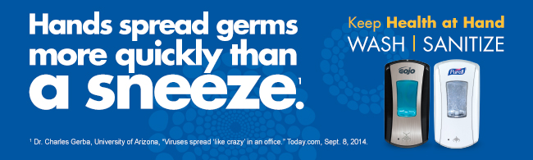

To: Employees

From: Building maintenance manager/HR

The cold, winter weather is here along with the illness-causing germs that come with it.

Your best defense against illness-causing germs this season is practicing good hand hygiene. With scientists noting hands spread germs more quickly than a sneeze, hand hygiene is the most effective and easiest way to stay healthy.

To help everyone stay well, PURELL**®** Advanced Hand Sanitizer and PURELL**®** 2-in-1 Sanitizing Wipes have been distributed throughout the office and GOJO**®** SANITARY SEALED™ Soap Systems are available at every sink.

Proper handwashing and hand sanitizing is always critical, but please be especially conscious during these key moments:

* after using the restroom;
* before and after eating;
* after coughing or sneezing; and
* after touching public surfaces.

We also recommend cleaning your workspace regularly, including your phone, desk, and computer keyboard. PURELL® 2-in-1 Sanitizing Wipes are the perfect way to safely clean surfaces and sanitize hands.

Thank you for helping us to keep health at hand this winter season.