**Post-season email template**

**Directions on how to use the email templates:** copy all of the content below, including the banner graphics and text, and paste content into a new email. You may then customize the text and send to your employees, customers, patrons etc.

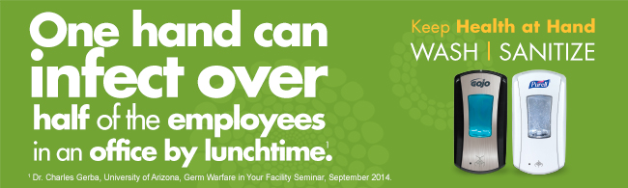

To: Employees

From: Building maintenance manager/HR

Spring is upon us, but don’t let your good hand hygiene habits disappear with the snow and colder temperatures.

Thank you for helping to keep our workplace healthy this season by practicing good hand hygiene. The preventive measures and germ-conscious habits our office has adopted over the past few months are good practices to keep year-round.

As we welcome the warmer temperatures, remember even one hand can infect many people in just a few hours, so we can keep health at hand all year by practicing good hand hygiene. To help you with this, we will continue to provide GOJO® SANITARY SEALED™ Soap Systems, PURELL**®** Advanced Hand Sanitizer and PURELL® 2-in1 Sanitizing Wipes.

Stay Well!