**Pre-season email template**

**Directions on how to use the email templates:** copy all of the content below, including the banner graphics and text, and paste content into a new email. You may then customize the text and send to your employees, customers, patrons etc.

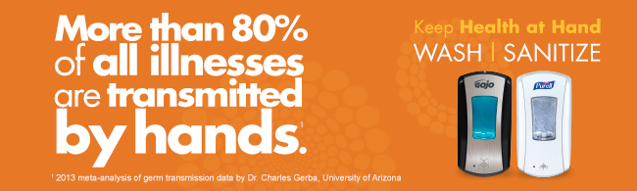

To: Employees

From: Building maintenance manager/HR

Winter germ season is quickly approaching, and this means now is the time to take an active role in protecting your health.

It has been reported that more than 80% of illnesses can be transmitted by the hands. In fact, germs can be found everywhere in the office – doorknobs, coffee pots and elevator buttons, to name a few of the hotspots. But there is one thing we can all do this winter germ season to stay healthy: Practice good hand hygiene.

Hand hygiene is the easiest and most effective way to stop the spread of illness-causing germs. This means washing your hands with soap and water for at least 20 seconds or using an alcohol-based hand sanitizer when soap and water is not available.

We want to make it easy for you to stay healthy by making PURELL**®** Advanced Hand Sanitizer and PURELL**®** 2-in-1 Sanitizing Wipes easy to access throughout your workday. This is just one way we will be keeping health at hand this winter germ season.

By incorporating these hand hygiene practices into your daily routine and encouraging these habits among others, our staff can stay healthy year round.